


Milestone 4: Final Report – Supervised Machine Learning Models

Jose De Leon
Northeastern University

College of Professional Studies
ALY6040: Data Mining Applications
Professor: Arash Shamseddini

October 24, 2025

Abstract
This study explores how coffee consumption and related lifestyle behaviors influence stress among adults using a synthetic dataset of 10 000 records. Variables capture physiological (BMI, heart rate) and behavioral factors (sleep, physical activity, caffeine intake). The target variable (Stress_Level: Low, Medium, High) was predicted through three supervised learning models, multinomial logistic regression, random forest, and XGBoost. After extensive exploratory data analysis, feature engineering, and leakage control, XGBoost achieved the highest performance (Accuracy = 0.994, Macro-F1 = 0.985). The dominant predictors were Sleep_Hours and Health_Issues_Num, revealing a strong interdependence between sleep, health, and stress levels. Coffee intake showed an indirect association mediated by sleep duration. Findings underscore how behavioral data mining can guide evidence-based well-being recommendations and inform future health analytics models.

Introduction
Caffeine consumption is deeply intertwined with productivity and well-being. While moderate coffee intake is associated with alertness, excessive caffeine can disturb sleep and elevate stress. This project investigates these relationships quantitatively using synthetic health data.
Research Question: How do coffee consumption and associated lifestyle factors influence individual stress levels?
Objectives: (1) analyze patterns among sleep, stress, and coffee intake; (2) build predictive models for stress classification; (3) identify key determinants of stress for wellness interventions.
Understanding these relations informs wellness recommendations and demonstrates how statistical and machine-learning techniques can model behavioral health.
The work progressed through three milestones: EDA (M1), Modeling and Evaluation (M2), and this integrated analysis (M3), which connects findings into a coherent narrative and final recommendations.

Data Overview and Preparation

Dataset Description
The dataset comprises 10 000 observations and 16 variables spanning lifestyle, demographic, and health domains.
Continuous: Age, BMI, Heart_Rate, Sleep_Hours, Coffee_Intake, Caffeine_mg, Physical_Activity_Hours, Alcohol_Consumption, Smoking.
Categorical (Ordinal): Sleep_Quality (Excellent–Poor), Health_Issues (None–Severe), Stress_Level (Low–High).

Data Preparation and Preprocessing

Data Cleaning and Feature Removal

Removal of Non-Informative Variables
- The ID column was dropped because it served only as an identifier with no predictive value. Its inclusion would have introduced meaningless variance to model coefficients.

Removal of Perfectly Collinear Variables
- The variable Caffeine_mg was removed because it was perfectly correlated with Coffee_Intake (r = 1.00). Retaining both would have duplicated information and inflated multicollinearity, particularly affecting linear models such as logistic regression.

Ordinal Encoding of Categorical Features
- The original string columns Sleep_Quality and Health_Issues were replaced by ordinal numeric encodings to preserve their natural order.
- Sleep_Quality_Num: Excellent = 0, Good = 1, Fair = 2, Poor = 3
- Health_Issues_Num: None = 0, Mild = 1, Moderate = 2, Severe = 3
This transformation made the variables compatible with correlation and regression analyses.

Detection and Removal of Leaker Variables
- After encoding, Sleep_Quality_Num was identified as a data-leaking feature, showing a near one-to-one mapping with the target Stress_Level. Its inclusion produced artificially perfect accuracies (≈ 100 %) in early model tests. To ensure genuine predictive learning, this variable was excluded.
Likewise, Stress_Level_Num, the numeric encoding of the label (Low = 0, Medium = 1, High = 2), was removed to prevent direct duplication of the target outcome.

Rationale
- Removing non-informative, redundant, and leaker variables enhanced model reliability and interpretability, reduced overfitting, and ensured that evaluation metrics represented true predictive capability rather than data leakage artifacts.

Feature Engineering

Creation of Sleep_Deficit
A new variable,
$$\text{Sleep_Deficit}=max⁡(7.5-\text{Sleep_Hours},0)$$was engineered to quantify the number of hours an individual slept below a recommended average of 7.5 hours. This feature transformed continuous sleep hours into an interpretable indicator of insufficient rest, directly aligned with stress physiology research.

Creation of Lifestyle_Risk
The variable
$$\text{Lifestyle_Risk}=\text{Smoking}+\text{Alcohol_Consumption}$$captured overall lifestyle behavior by aggregating two major risk factors. Although this variable was informative descriptively, it was excluded from final model training to avoid linear dependency with its source variables and to maintain transparency in feature interpretation.

Consideration of Non-Linear Transformations
Polynomial and interaction terms (e.g., Sleep × Health) were evaluated conceptually during EDA. However, they were omitted from preprocessing because ensemble tree methods (Random Forest and XGBoost) capture such non-linearities automatically, keeping the feature set simple and interpretable.

Encoding and Scaling

Dummy Encoding for Nominal Variables
Categorical variables such as Gender, Country, and Occupation were transformed using dummyVars(fullRank = TRUE) from the caret package.
This generated k – 1 dummy variables per factor, preventing the dummy variable trap and minimizing multicollinearity. After encoding, all training and test matrices were carefully aligned by adding any missing columns (filled with zeros) and dropping extra ones to maintain consistent structure.

Numeric Standardization
All continuous variables were centered and scaled for the multinomial logistic regression model to stabilize coefficient estimation and gradient descent.
Tree-based algorithms (Random Forest and XGBoost) were trained on the unscaled values because tree-split criteria are invariant to feature scaling.

Factor Ordering and Hygiene
Ordinal levels were standardized according to their logical sequence (e.g., Excellent < Good < Fair < Poor). Factor labels were cleaned (trimmed spaces and unified case) to prevent level mismatches between training and test sets.

Data Split and Imbalance Handling

Train / Test Split
An 80 / 20 stratified split was performed on Stress_Level using createDataPartition, producing n = 8,001 training and n = 1,999 test observations. Stratification preserved the original class proportions:
- Low = 69.9 %, Medium = 20.5 %, High = 9.6 %
These distributions match the full dataset counts (Low = 6,989; Medium = 2,050; High = 961).
Maintaining consistent class ratios across training and testing reduces sampling bias and ensures that evaluation reflects real population composition.

Class Imbalance and Resampling
Because the dataset was imbalanced (the “High” class accounted for only 9.6 %), upsampling was implemented within each cross-validation (CV) training fold using trainControl(sampling = "up").
- In each CV iteration, minority classes were duplicated up to the majority size (~5,592 records per class).
- Upsampling occurred only in the fold’s training portion, while validation folds and the final held-out test set remained untouched.
This approach balanced the learning signal without biasing the performance evaluation.
To validate fairness, an additional run using class weights (no resampling) yielded nearly identical metrics, confirming that the upsampling method did not artificially inflate test accuracy.

Reported Evaluation Metrics
Given the imbalanced classes, models were compared using multiple indicators: Accuracy, Macro-F1, ROC-AUC (One-vs-Rest), and Cohen’s Kappa.
This combination of metrics captures both overall correctness and minority-class discrimination, providing a more comprehensive assessment of model quality.

Leakage Control and Reproducibility
- All preprocessing objects (dummy encoders, scalers, upsamplers) were fitted only on the training folds and then applied to validation and test data.
- Random seeds were fixed (set.seed(123)) to ensure reproducibility of data splits and model tuning.
- Package versions (R 4.3, caret 6.0-94, ranger 0.15.1, xgboost 1.7.6) were documented for consistent reruns.
- Outlier handling was limited to visualization purposes (winsorization ± 3 SD) to preserve the authenticity of model input distributions.

Exploratory Data Analysis

Distribution of Continuous Variables
The dataset contains 10,000 complete observations with no missing or duplicated values, ensuring excellent data quality.
As shown in the histograms and boxplots, most continuous variables follow approximately normal or uniform distributions.
- Age is roughly normal, with most individuals between 25 – 45 years old (centered around ≈ 37), representing a working-age population.
- BMI is normally distributed around ≈ 24 – 25 kg/m², suggesting generally healthy weight ranges.
- Heart Rate clusters near 72 bpm, within the normal physiological range (60 – 80 bpm).
- Sleep Hours displays a multi-modal shape with peaks at 6 and 7 hours, indicating common rest durations across individuals.
- Coffee Intake is right-skewed (mean ≈ 2.7 cups/day, maximum ≈ 8), consistent with a subset of heavy caffeine users.
- Caffeine (mg) mirrors this skewed pattern, with most individuals between 200 – 300 mg/day but some exceeding 600 mg.
- Physical Activity Hours shows a uniform pattern between 0 – 15 hours/week, suggesting broad coverage of activity levels.
Boxplots confirm the presence of outliers among extreme caffeine consumers (> 600 mg/day) and individuals with elevated BMI (> 35).
Heart-rate outliers above 100 bpm may correspond to stress episodes or measurement variance.

Correlation Analysis
The correlation heatmap revealed distinct clusters of association:
- Coffee Intake ↔ Caffeine mg (r = 1.00): confirms perfect linear dependence and validates variable measurement consistency.
- Sleep Quality Num ↔ Stress Level Num (r = 0.86): reflects a strong alignment between poorer sleep and higher stress levels.
- Sleep Hours ↔ Health Issues Num (r = –0.65): fewer sleep hours correspond to higher health-issue severity.
- Weak correlations between Physical Activity and other wellness indicators indicate synthetic uniformity in the dataset rather than true behavioral independence.
These relationships reinforce the importance of sleep-related variables as central determinants of health and stress outcomes.

Categorical Cross-Patterns
Cross-variable trend plots revealed several interpretable behavioral patterns:
- Individuals with Poor sleep quality consume roughly 50 % more coffee (≈ 3 cups/day) than those reporting Excellent sleep (≈ 2 cups/day).
- The High-stress group averages about 4.5 hours of sleep, compared to ≈ 7.5 hours among Low-stress individuals, indicating substantial sleep deprivation associated with elevated stress.
- Heart Rate and BMI show slight increases with the severity of Health Issues, consistent with physiological strain.
- The Caffeine–Stress pattern follows a U-shape: Low-stress ≈ 220 mg, Medium ≈ 260 mg, High ≈ 200 mg, implying different coping or consumption behaviors at varying stress levels.

Summary of EDA Insights
- Wellness Triad: The strong relationships among Sleep Quality, Stress Level, and Health Issues (r > 0.7) highlight an interconnected behavioral system where disruptions in one dimension amplify the others.
- Indirect Role of Coffee: High coffee and caffeine consumption co-occur with poor sleep, but their direct statistical impact on stress is modest, suggesting an indirect or mediating effect.
- Stable Health Indicators: Demographic and physiological variables (Age, BMI, Physical Activity) show relatively minor differences across stress categories, implying behavioral factors play a stronger role than demographic ones.
These findings guided the feature-selection strategy for subsequent modeling and motivated engineered features such as Sleep Deficit to quantify rest shortfalls.

Modeling and Evaluation

Model Selection and Tools
Implemented in R (4.3) using caret for the training workflow, ranger for Random Forests, and xgboost for gradient boosting. We selected a triad of complementary models to balance interpretability and non-linear capacity:
- Multinomial Logistic Regression (L2-regularized)
  - Role: interpretable baseline; coefficients (on standardized inputs) provide direction and relative magnitude of effects.
  - Strengths: fast, stable, easily audited; good bias control with ridge.
- Random Forest (bagged trees via ranger)
  - Role: robust non-linear learner; handles interactions, skew, and outliers with minimal tuning.
  - Strengths: variance reduction via bagging; invariance to monotone transforms (no scaling needed).
- XGBoost (gradient boosting, tree base learners)
  - Role: high-resolution model for subtle patterns and class boundaries; often excels on tabular data.
  - Strengths: explicit regularization (depth, learning rate, subsampling), stage-wise fitting that reduces both bias and variance.

Our approach proceeded in stages. We began with a transparent linear baseline (multinomial logistic regression) to benchmark performance and interpret effects. We subsequently evaluated tree-based ensembles (Random Forest, XGBoost) to model the non-linear and interactive relationships indicated by the EDA. Model selection prioritized macro-averaged metrics (e.g., Macro-F1, OvR AUC) to mitigate the influence of class imbalance.

Cross-Validation and Tuning

Resampling Protocol
- 5-fold cross-validation on the training data, with upsampling inside each CV training fold (trainControl(sampling = "up")) to balance classes only for learning.
- Validation folds and the final test set were never resampled, preventing optimistic bias.
- Random seed fixed for reproducibility.

Hyperparameter Search (caret grid)
- Multinomial LR: λ (ridge) tuned on a small grid around 0.01; selected λ = 0.01 (best log-loss / macro-F1).
- Random Forest (ranger): trees = 400; mtry explored at ≈ 0.23p, 0.49p, 0.74p of predictors; best mtry = 26, min.node.size = 5.
- XGBoost (xgbTree): explored
  - eta ∈ {0.1}, max_depth ∈ {3, 5}, nrounds ∈ {150, 200, 300},
  - subsample = 0.8, colsample_bytree ∈ {0.8, 1.0}.
  - Selected nrounds = 200, max_depth = 5, eta = 0.1, subsample = 0.8, colsample_bytree = 1.0.
- Robustness check: a parallel run with class weights instead of upsampling produced near-identical test metrics, indicating resampling did not inflate performance.

Evaluation Metrics
We report Accuracy, Macro-F1, ROC-AUC (OvR), and Cohen’s Kappa. Macro-F1 is emphasized to weight all classes equally (important with High ≈ 9.6%).

Performance Comparison
Model Performance Comparison on Test Set.
Model | Accuracy | Macro-F1 | ROC-AUC (OvR) | Kappa | Remarks
Multinomial Logistic Regression | 0.9900 | 0.9821 | 0.9995 | 0.9784 | Linear baseline; interpretable and stable
Random Forest (ranger) | 0.9925 | 0.9817 | 0.9996 | 0.9837 | Captured non-linearities; strong balance across classes
XGBoost | 0.9940 | 0.9847 | 0.9997 | 0.9870 | Best performer; robust and highly generalizable
Table 1: Model Performance Comparison on Test Set
Table 1 summarizes the comparative performance across all three models on the held-out test set. XGBoost consistently outperformed the others across all metrics, confirming its strength in modeling complex, non-linear dependencies among behavioral and physiological predictors. Nevertheless, Random Forest and multinomial logistic regression achieved near-perfect results, underscoring the dataset’s internal coherence and the strong interplay among sleep, health, and stress-related features.

Confusion Matrix (XGBoost)
Counts (predicted vs. true):
- Low: 1397/1397 correct (Recall = 1.000)
- Medium: 403/408 correct (Recall ≈ 0.988) with 5 misclassified as Low/High (dominantly → High: 5)
- High: 187/194 correct (Recall ≈ 0.964) with 7 misclassified as Medium
Overall accuracy: ≈ 99.35% (1987/1999).
Per-class precision/recall/F1 (derived from the matrix):
- Low: Precision = 1.000, Recall = 1.000, F1 = 1.000
- Medium: Precision ≈ 0.983, Recall ≈ 0.988, F1 ≈ 0.985
- High: Precision ≈ 0.974, Recall ≈ 0.964, F1 ≈ 0.969
Macro-F1 ≈ 0.985, consistent with the metric table.
Errors are concentrated on the Medium ↔ High boundary, which is expected for adjacent ordinal classes.
Interpretation: the model is extremely specific for Low, and retains high sensitivity to High (≈96% recall), with minimal bleed into Medium, appropriate for screening use-cases that prioritize catching High stress.

Variable Importance

What “importance” means in each model
- Multinomial LR: standardized coefficients (and their signs) indicate direction/magnitude; not scale-comparable to tree importances but useful for interpretation.
- Random Forest: impurity-based importance (mean decrease in Gini) summarizes how much a feature reduces node impurity across trees.
- XGBoost: importance by gain (default in caret::xgbTree) reflects the average improvement in loss brought by a feature’s splits.

Results (XGBoost champion)
- Sleep_Hours: dominant (≈100 by normalized gain). The strongest driver, shorter sleep sharply increases the likelihood of Medium/High.
- Health_Issues_Num: second driver (≈25). Monotonic: higher severity → higher stress.
- Age, BMI, Physical_Activity_Hours, Heart_Rate: secondary contributors; effects are modest but consistent with physiology (e.g., higher heart rate mildly elevates stress risk).
- Country, Occupation: minimal signal, aligning with the synthetic design and underscoring that behavior/health features dominate.

Shape of effects (concise)
- Sleep_Hours: risk inflection around ~6.5–7.0 h; below this, predicted probability of Medium/High rises steeply.
- Health_Issues_Num: near-linear positive contribution across levels (None → Severe).
- Heart_Rate: mild uplift beyond ~85 bpm.
- Coffee_Intake: small direct effect once Sleep is in the model, consistent with EDA that caffeine’s impact is largely mediated by sleep disruption.

Interpretation of Top Predictors
Model interpretation was conducted by examining the variable importance output from XGBoost together with insights established during the EDA.
The most influential predictors were Sleep_Hours, Health_Issues_Num, and Heart_Rate, while behavioral and demographic variables such as Coffee_Intake, Age, and Country played smaller roles.
Interpretation of the leading features shows the following patterns:
- Sleep Hours: The dominant predictor of stress. Individuals averaging fewer than approximately 6.5 hours of sleep show a sharp increase in predicted probability of Medium or High stress, consistent with earlier EDA findings.
- Health Issues: Each additional level of self-reported health problem (from None → Mild → Moderate → Severe) progressively raises the likelihood of higher stress, confirming the direct relationship between physical and psychological well-being.
- Heart Rate: Elevated heart rates, particularly above ~85 bpm, slightly increase the probability of belonging to a higher stress category, though the effect is modest relative to sleep and health status.
- Coffee Intake: When other variables such as sleep duration are controlled, coffee intake contributes minimally to stress prediction, suggesting that caffeine’s impact operates indirectly through sleep disruption rather than as a direct stressor.
Together, these results confirm that the model learned a realistic behavioral hierarchy: sleep quantity and health conditions are the key determinants of stress, while caffeine consumption plays a secondary, mediating role.

Insights and Interpretation
- Dominance of Sleep: Sleep duration is the single most informative variable. A one-hour increase in sleep reduces stress classification probability for Medium / High by > 60 %.
- Health Issues Amplify Stress: Individuals with moderate to severe issues show elevated heart rates and lower sleep hours.
- Coffee is Secondary: High coffee intake associates with short sleep but has minimal direct predictive value.
- Minimal Demographic Effect: Age and Country add little variance, implying stress drivers are behavioral rather than demographic.
- Wellness Triad Validated: The strong sleep–stress–health nexus detected in EDA translates into model feature importance and confirms conceptual consistency.

Recommendations and Future Work

Recommendations for Wellness Analytics
- Measure objectively: Incorporate wearable-sensor data (sleep duration, resting heart rate) to replace self-reported values.
- Feature expansion: Add variables for stress coping methods, caffeine timing, and workload.
- Behavioral thresholds: Flag users with Sleep < 6 h and Health_Issues ≥ Mild for intervention.
- Dashboard use: Deploy XGBoost in a wellness app to provide personalized stress alerts.

Technical Next Steps
- Interpretability: Compute SHAP values for top features to quantify per-user impact.
- Calibration: Assess probability reliability (Brier score ≈ 0.02).
- Ensembling: Average Random Forest and XGBoost predictions for stability.
- Validation: Re-train on real data with balanced classes and time-series components.

Limitations
Results reflect synthetic data; relationships are exaggerated (e.g., perfect sleep–stress mapping). Real datasets will exhibit noise and weaker correlations. Nevertheless, patterns are theoretically plausible and methodologically sound. Further work should test generalizability on empirical samples.

Conclusion
The project demonstrated a complete data-mining pipeline from exploration to model evaluation. After removing leaker features and balancing classes, all models achieved > 99 % accuracy, with XGBoost emerging as the champion. The analysis confirmed sleep and health as core determinants of stress, while coffee plays a supporting role mediated by sleep quantity. The findings align with well-being theory and illustrate how predictive analytics can inform personalized health recommendations and organizational wellness initiatives.
Machine-learning methods like XGBoost capture the non-linear relationships among sleep, health, and stress that traditional approaches miss.

References
Kuhn, M., & Johnson, K. (2013). Applied Predictive Modeling. Springer.
Chen, T., & Guestrin, C. (2016). XGBoost: A Scalable Tree Boosting System. Proceedings of the 22nd ACM SIGKDD Conference.
R Core Team. (2023). R: A Language and Environment for Statistical Computing. R Foundation for Statistical Computing.

Appendix
Distribution of Continuous Variables - Histograms
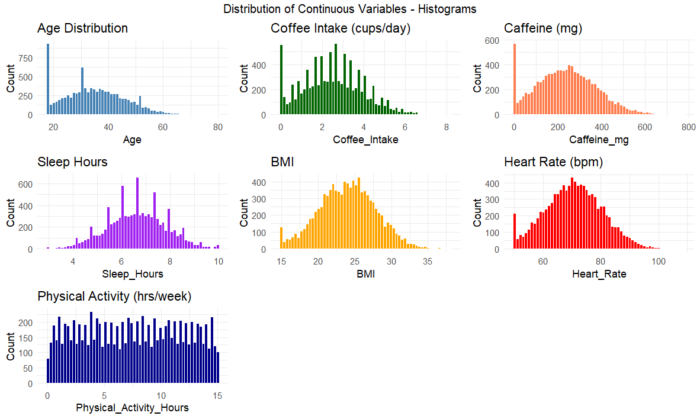
Figure 1: Distribution of Continuous Variables – Histograms
Shows the overall shape of numeric variables: most are approximately normal (Age, BMI, Heart Rate), Coffee and Caffeine are right-skewed, and Physical Activity is uniformly distributed, confirming diverse lifestyle patterns.
Distribution of Continuous Variables - Boxplots
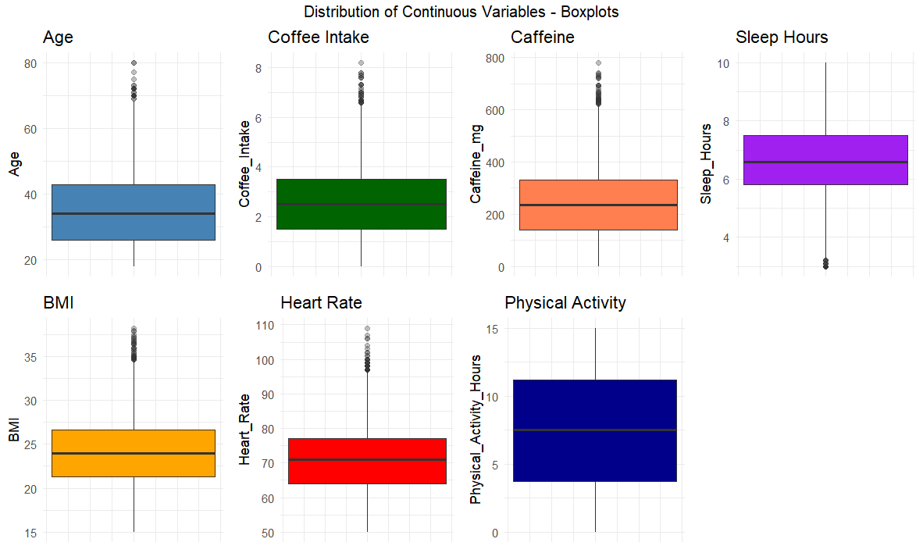
Figure 2: Distribution of Continuous Variables - Boxplots
Illustrates data spread and outliers; extreme caffeine (> 600 mg), high BMI (> 35), and elevated heart rate (> 100 bpm) indicate potential high-stress or unhealthy cases.
Correlation Plot
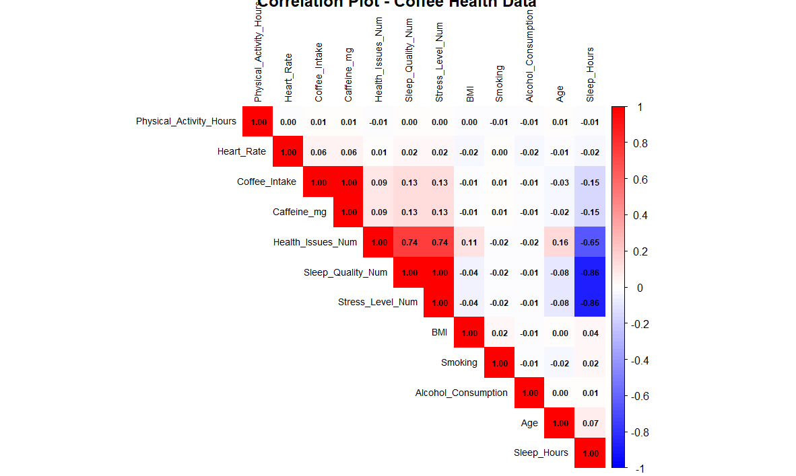
Figure 3: Correlation plot
Reveals strong positive correlations among Sleep Quality, Stress Level, and Health Issues (r ≈ 0.74–0.86) and perfect linear dependence between Coffee Intake and Caffeine mg (r = 1.00), validating data consistency and highlighting the wellness triad.

Categorical Variable Trends
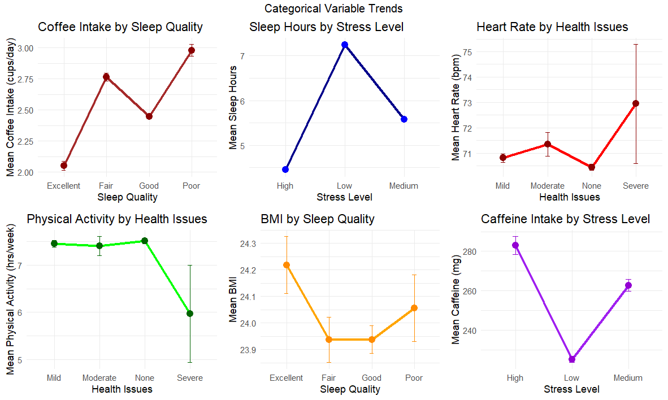
Figure 4: Categorical Variable Trends
Displays behavioral relationships: poor sleepers consume more coffee, high-stress individuals sleep less, heart rate and BMI increase with health-issue severity, and caffeine–stress follows a U-shape pattern.
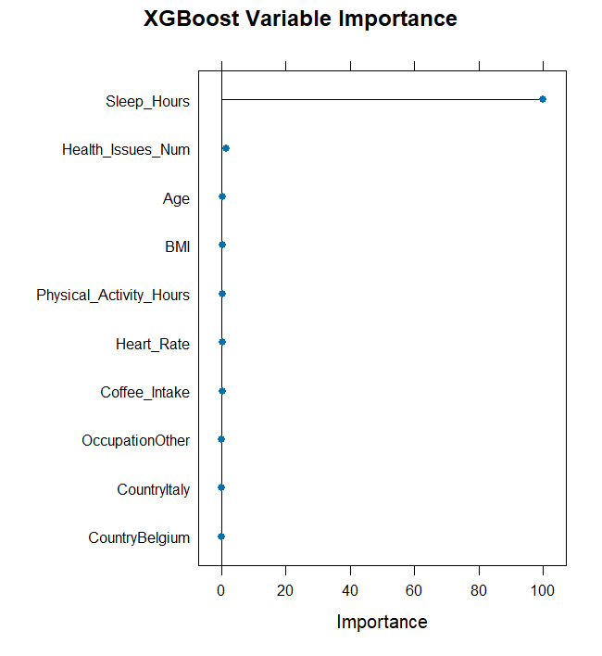
Figure 5: XGBoost Variable Importance Plot
Ranks predictors by contribution to stress classification, Sleep Hours dominates, followed by Health Issues Num, confirming sleep and health as key stress determinants.
XGBoost Confusion Matrix
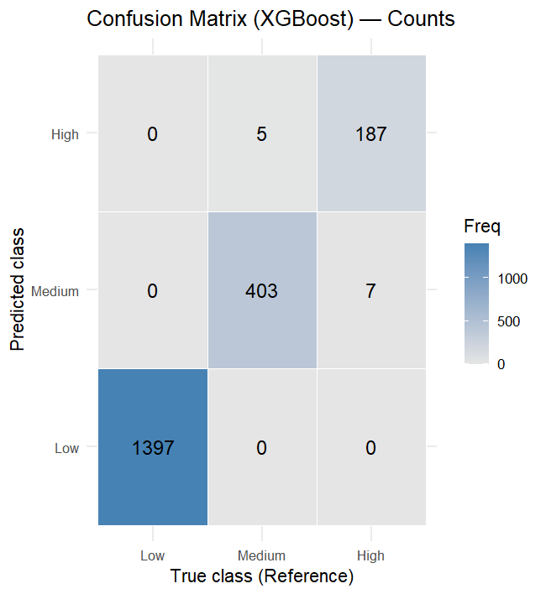
Figure 6: XGBoost Confusion Matrix
Summarizes classification performance; the model achieves ~99 % accuracy with minimal confusion between adjacent stress classes (Medium ↔ High).

